HR 2 BREAKDOWN

TEAM: Team Malawi- 20F03

Due Date: Friday, March 19, 2021, at 11:59pm

Provide several pics of the current state of your completed system thus far here:

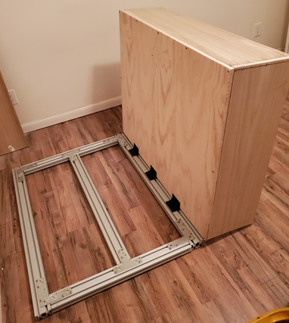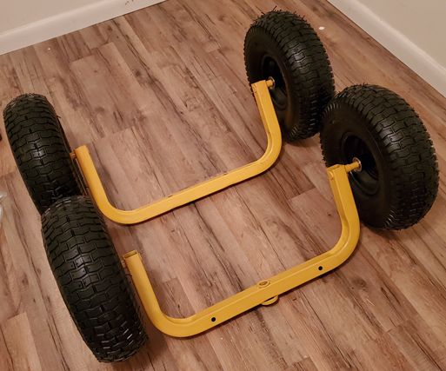
The first image above is the current state of the frame. It has the bucket attached through the hinges to allow for dumping. The second image is the wheel and axle assembly, currently. Changes will be made to the rear axle to assist with being driven by the motor.

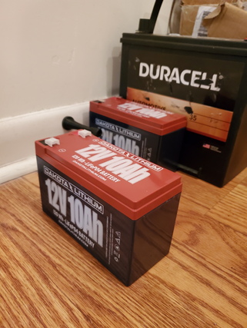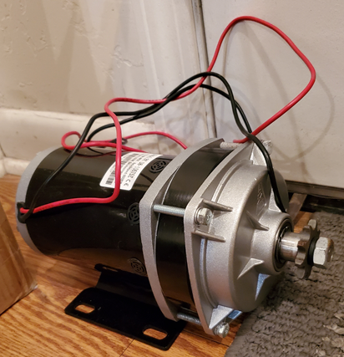
These two images are images of the components for the electrical part of this design. The motor will be connected to the batteries via a speed controller and will be driven by a twist throttle handle.
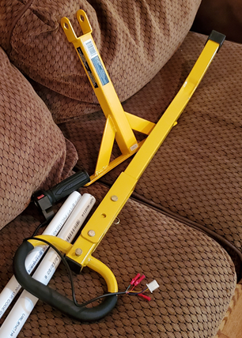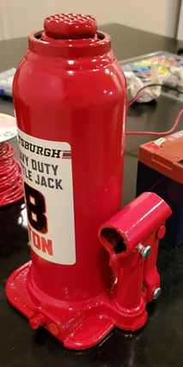
The above image on the left is the components for the steering system. Modifications are currently in the process to accommodate for the twist throttle. On the right above is the hydraulic jack that will be used to lift the bucket from the frame. The PVC in the left image is also be used as an extended handle for this jack.

The following are the Action Items each person completed between Hardware Review 1 and Hardware Review 2:

Team Member: Husain Aldawood
Action Item | Date Completed | Result/Proof of Completion
Researched more on tires and found the best vendor for tires, axles, and handle for the cart then I created a purchase order form of the parts needed and sent it to the team’s budget manager. | 2/22/2021 | 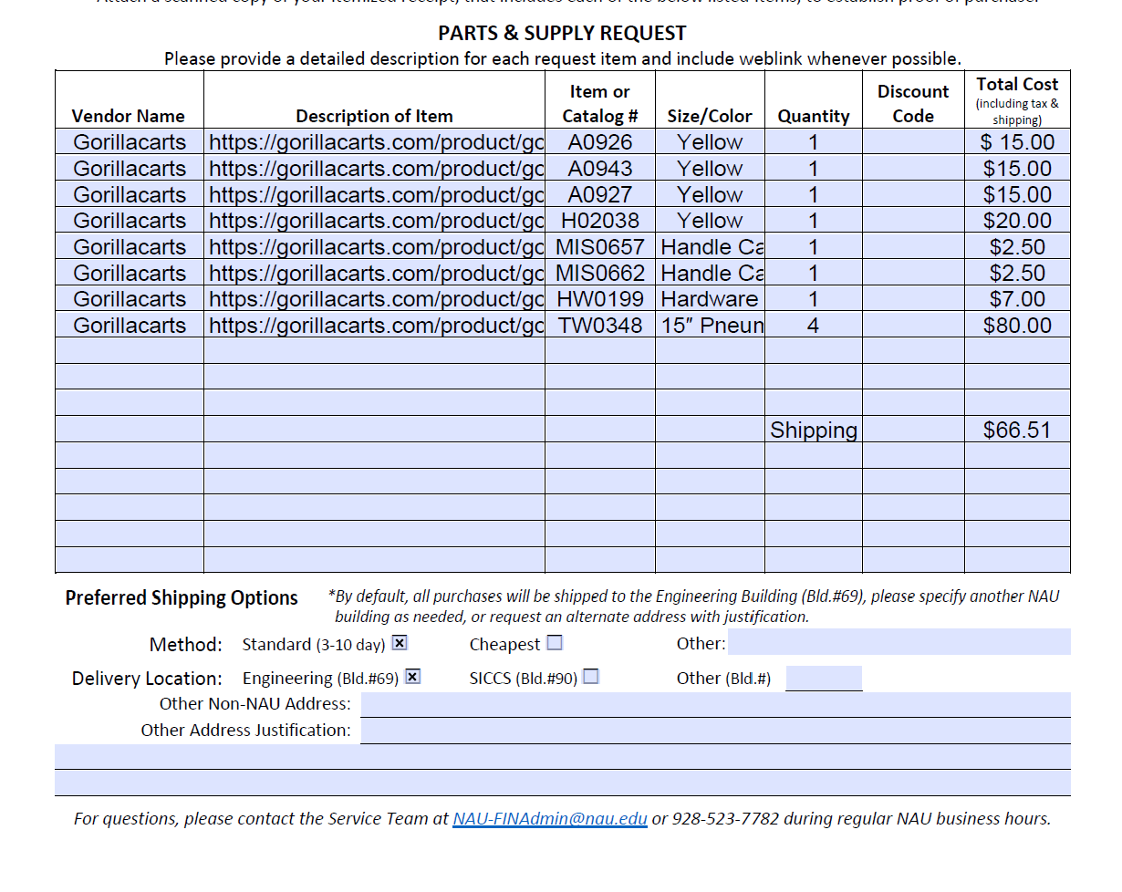
Got the rest of the needed supply from HomeCO and began the building process. | 3/11/2021 | 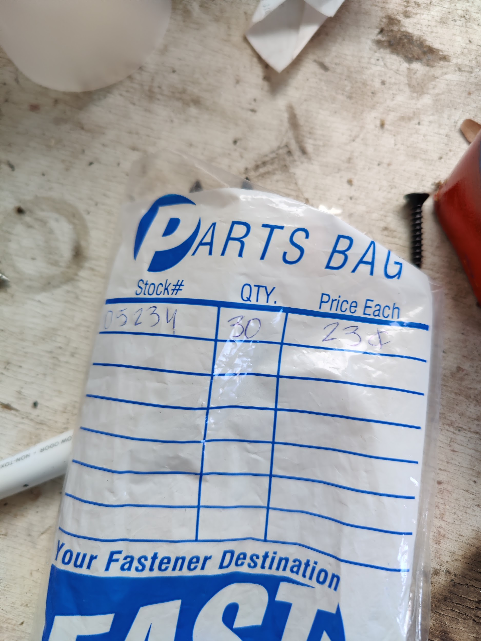
Met with the team to finish up building the frame and putting together the wood needed for the basket of our cart. | 3/15/2021 | 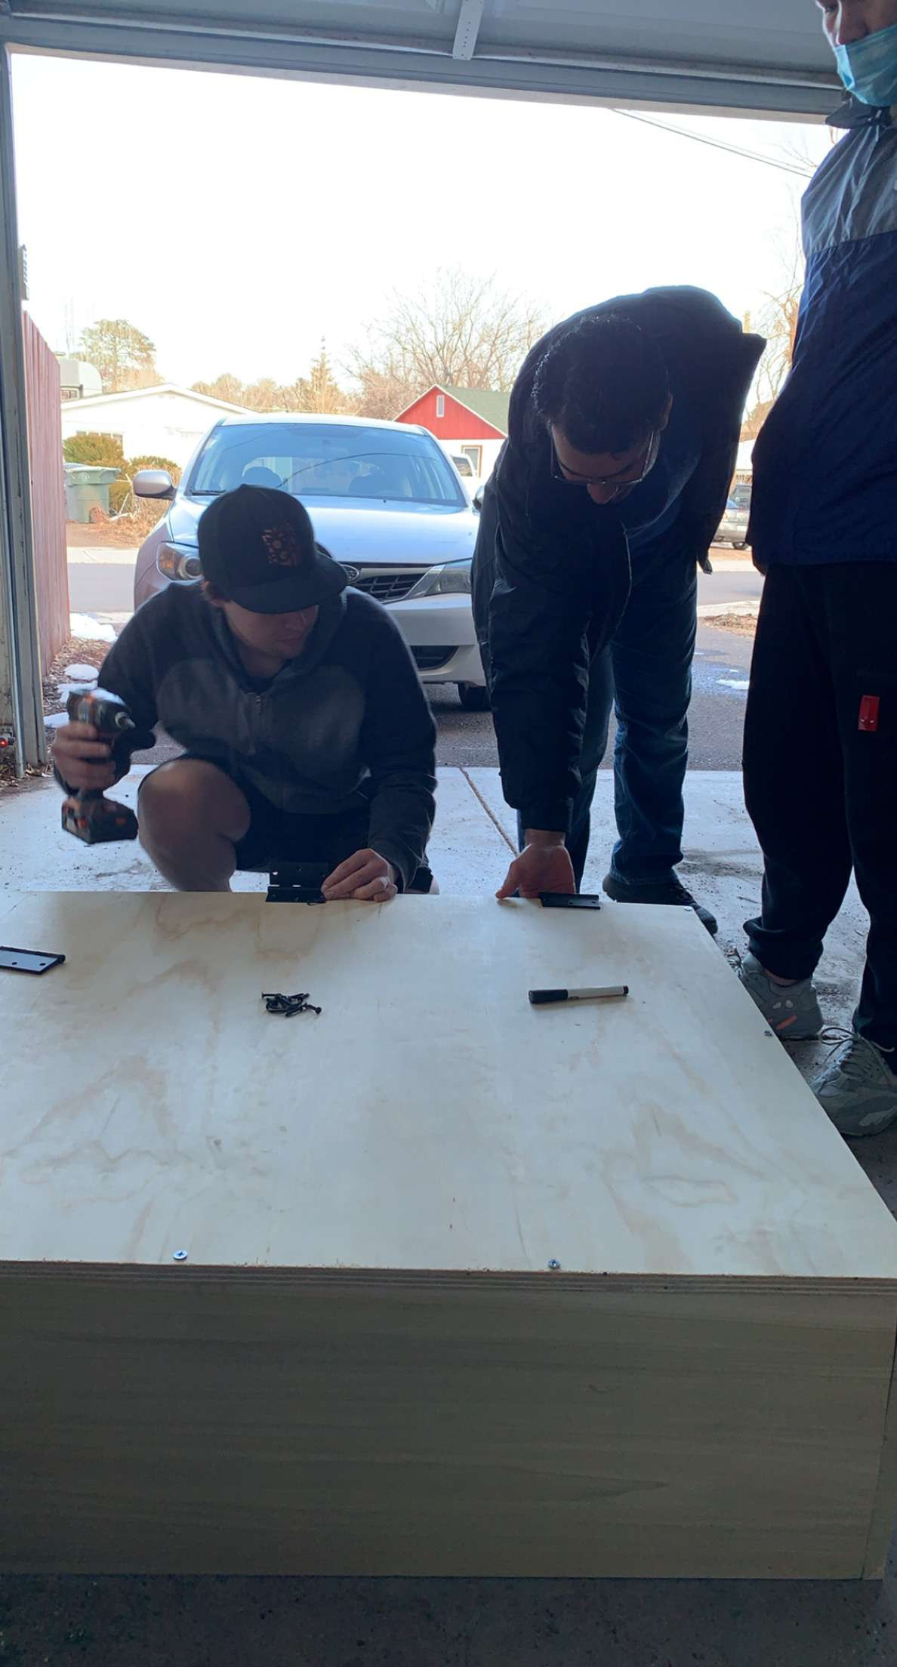

Team Member: Connor Schmerfeld
Action Item | Date Completed | Result/Proof of Completion
Once received, I cut the 8020 Aluminum beams into the required sizes for the frame. | 3/8/2021 | 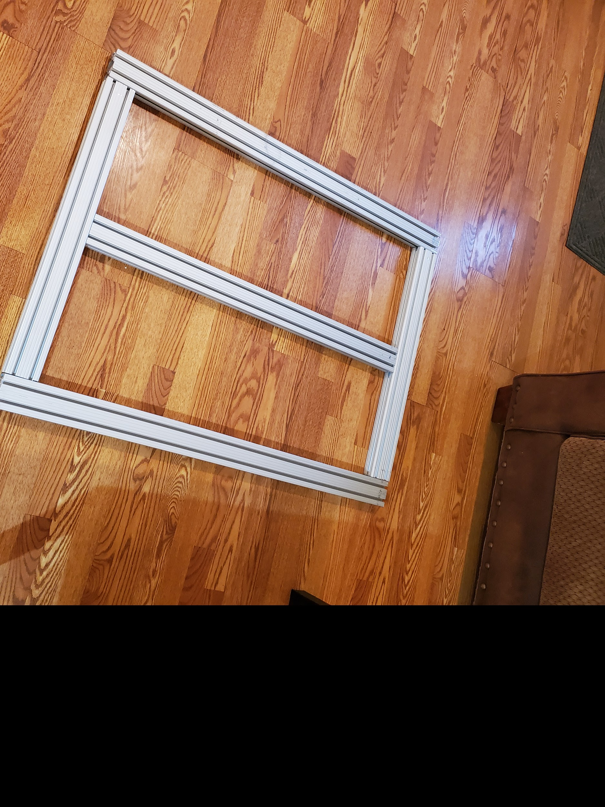
Cut the wood boards into the proper size for the walls of the design. | 3/11/2021 | 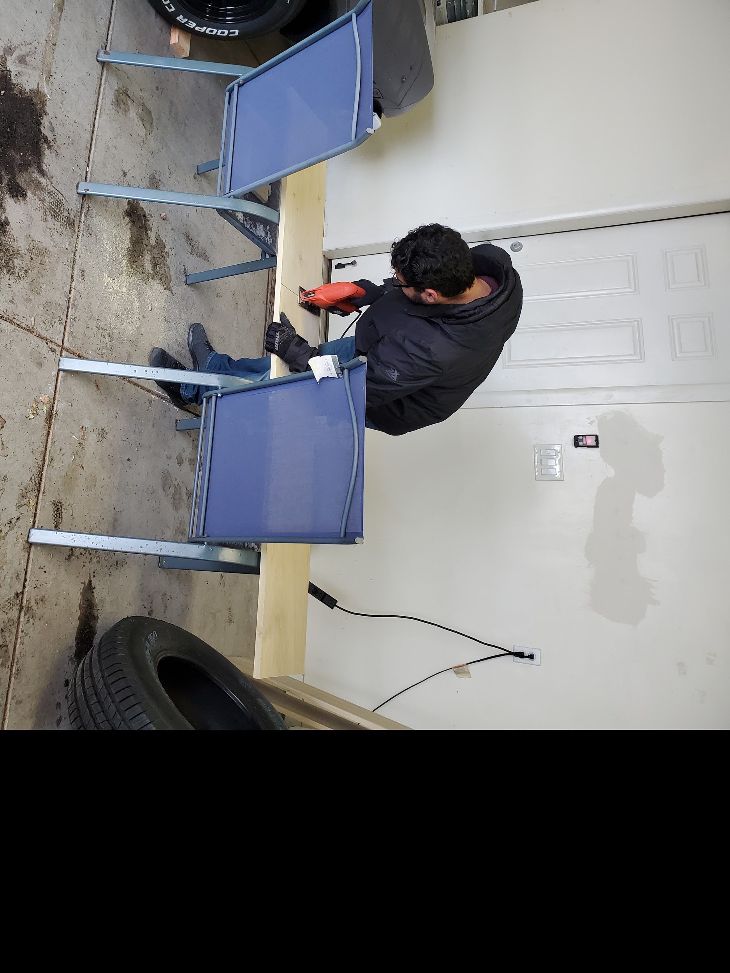
Met with the team to buy the necessary parts to assemble the walls onto the base, as well as fit the pieces of the frame together. This included drilling holes and screwing together the wooden pieces, as well as screwing the holes necessary into the aluminum to fit the brackets on. | 3/15/2021 | 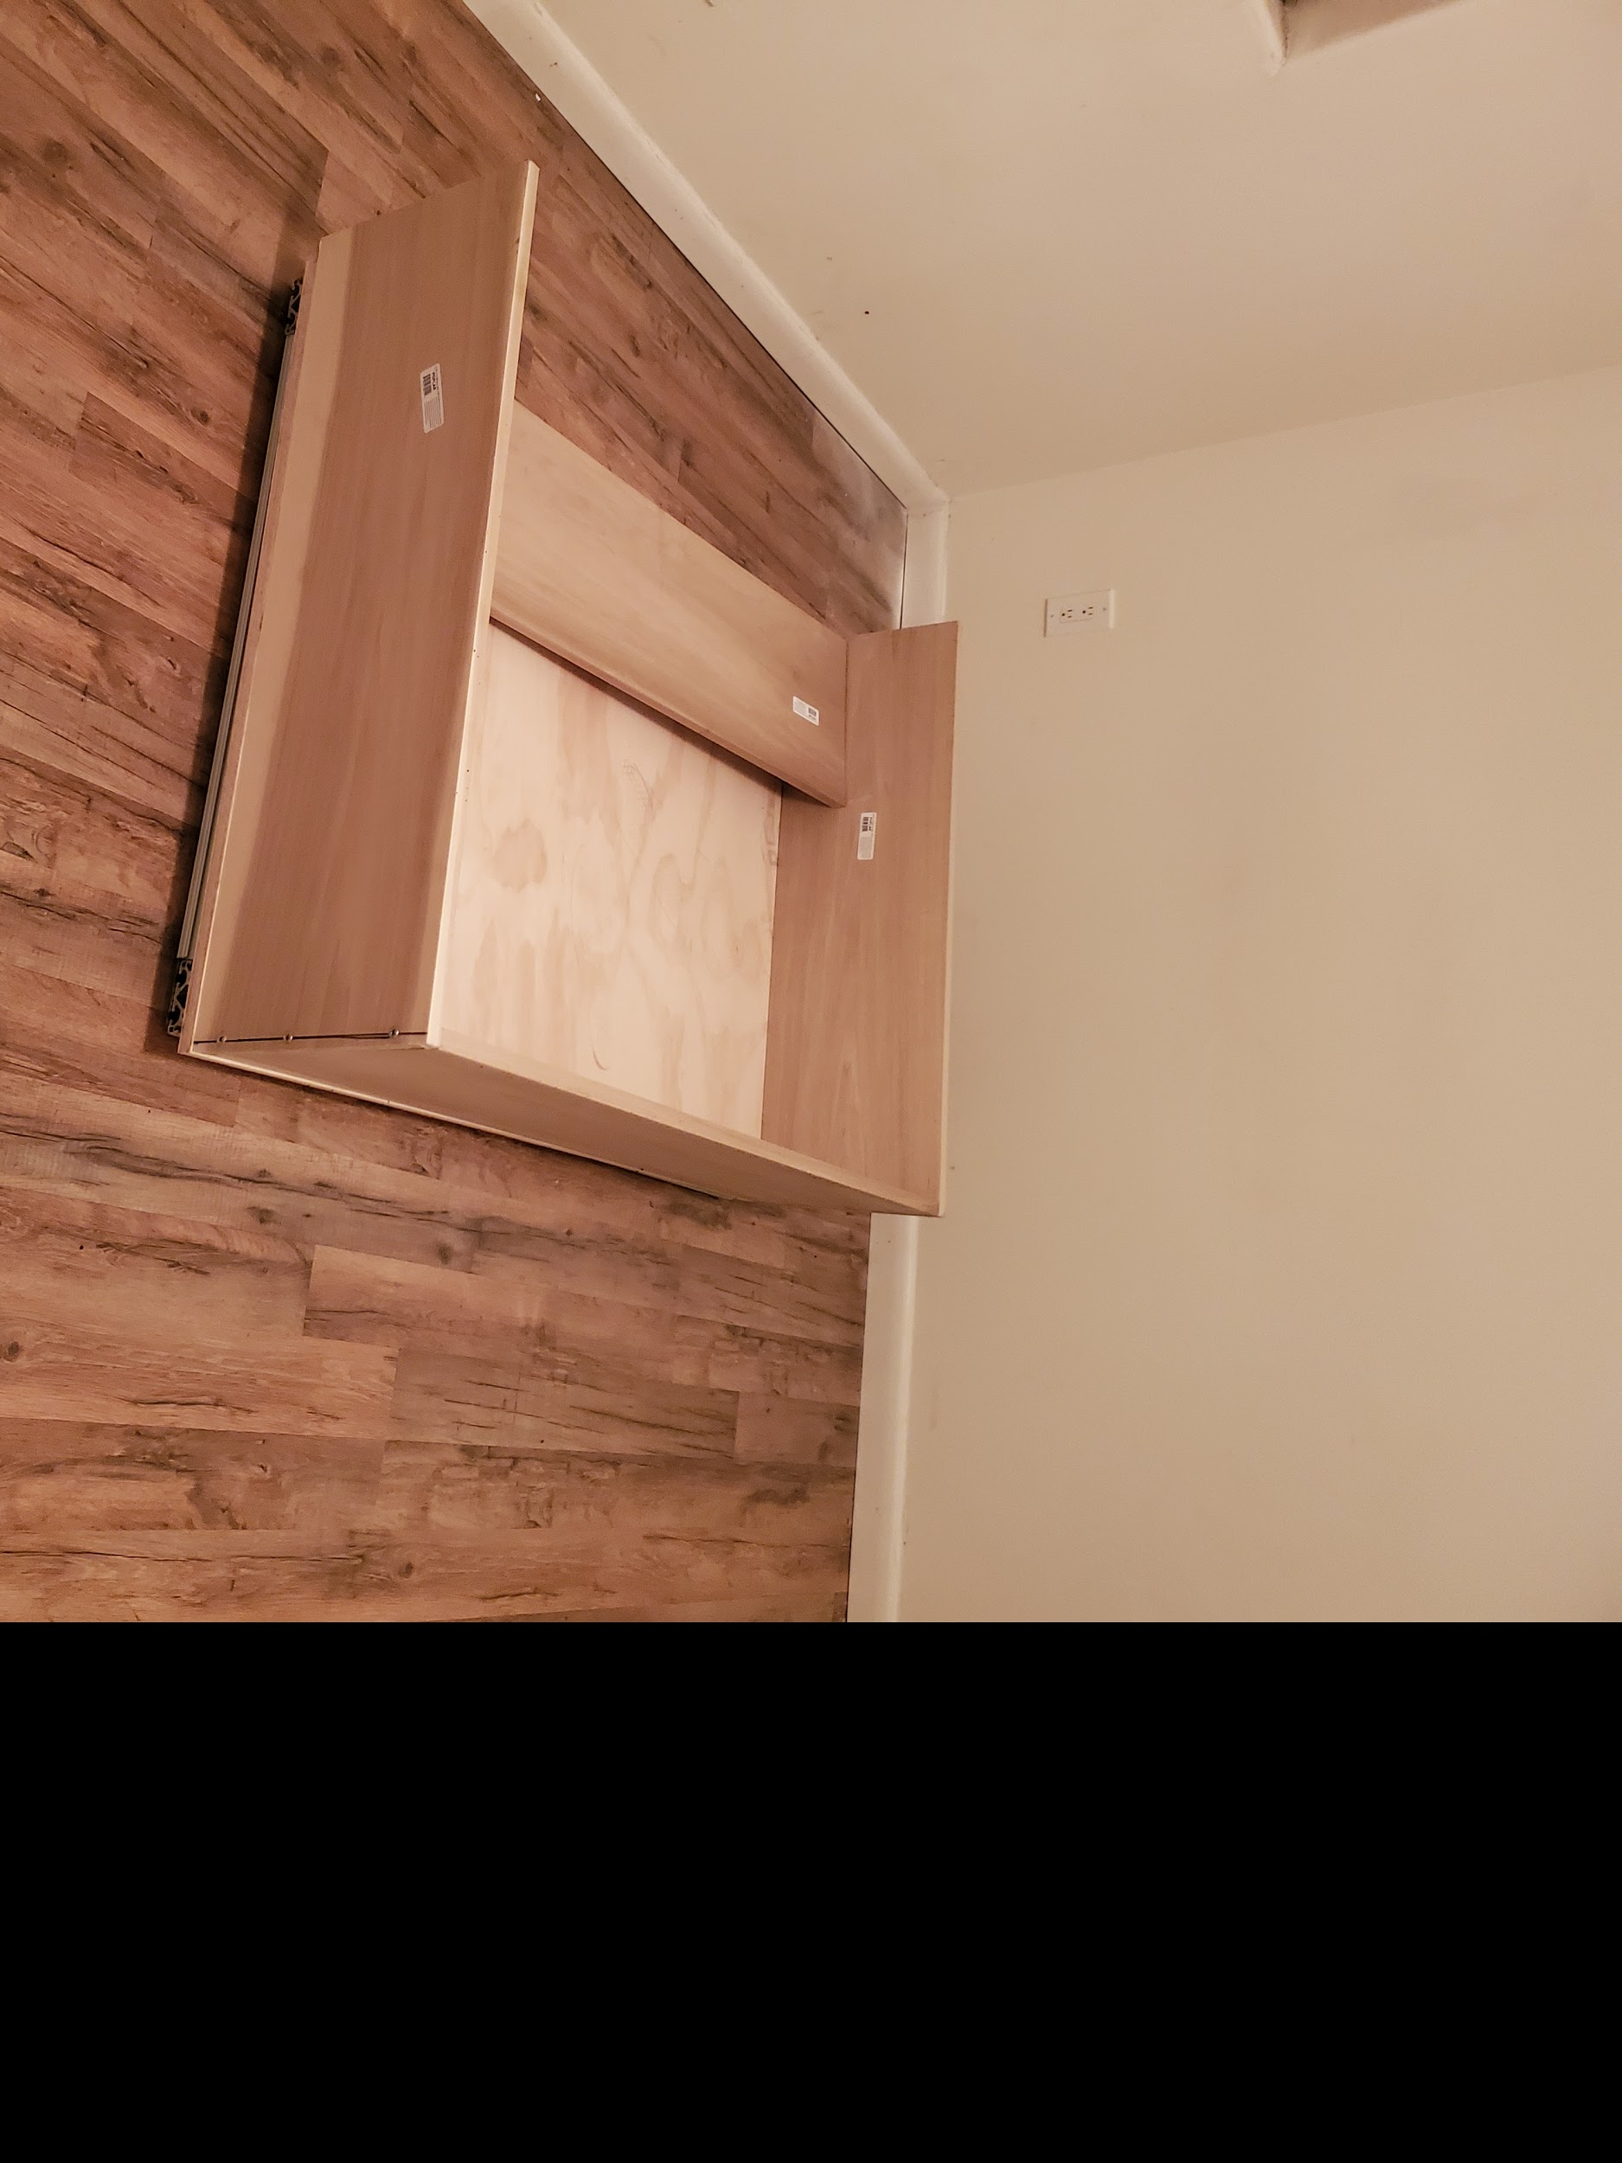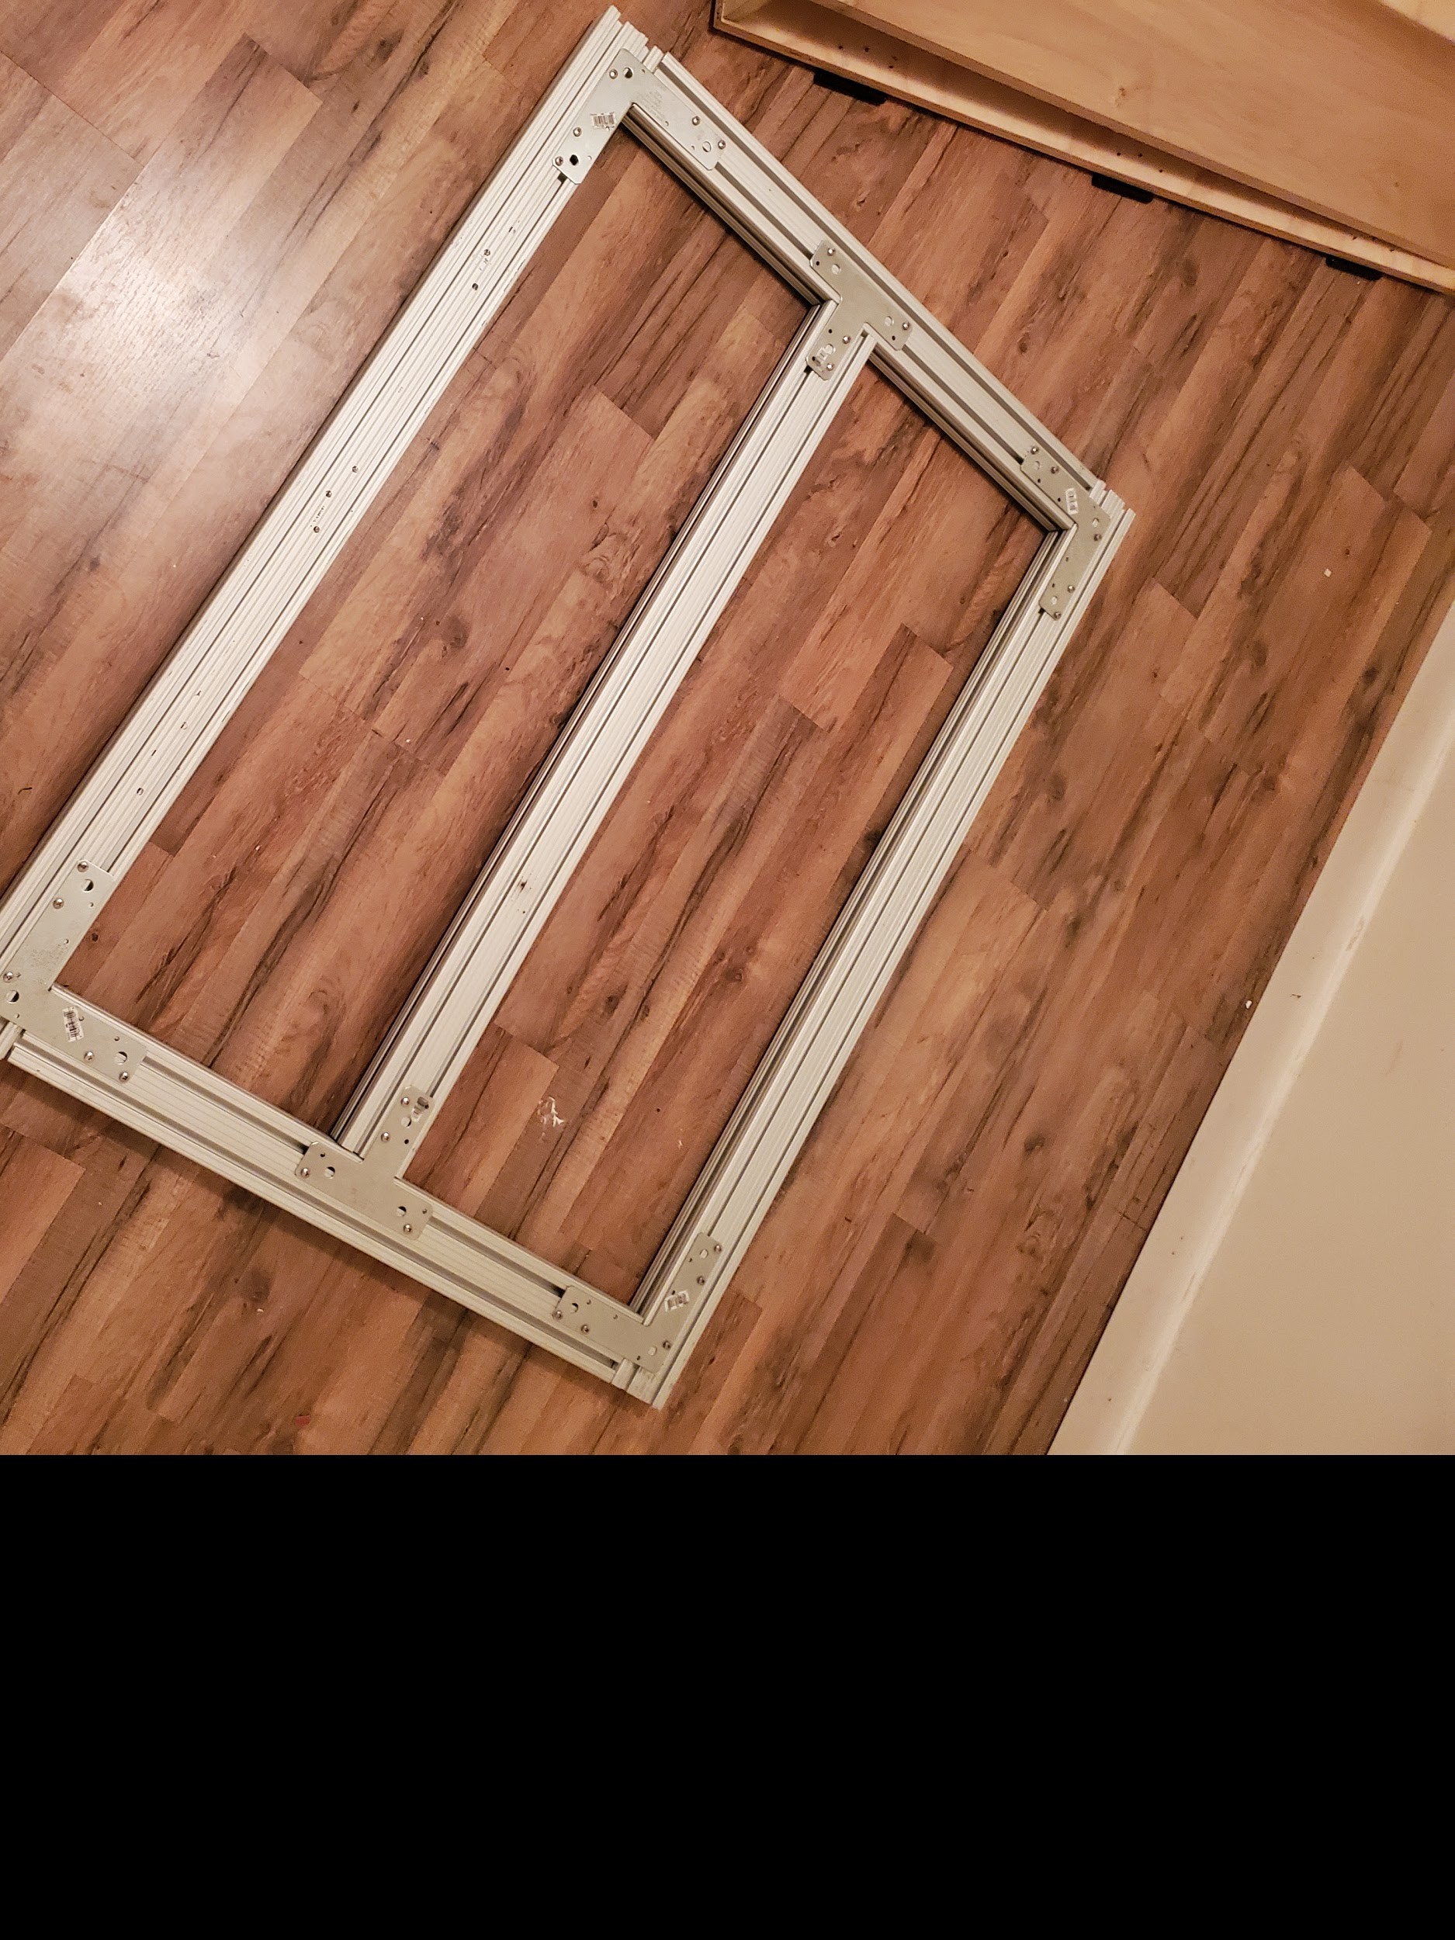
Put the hinges on to connect the frame to the bucket piece so now we have a function dumping bucket. | 3/18/2021 | 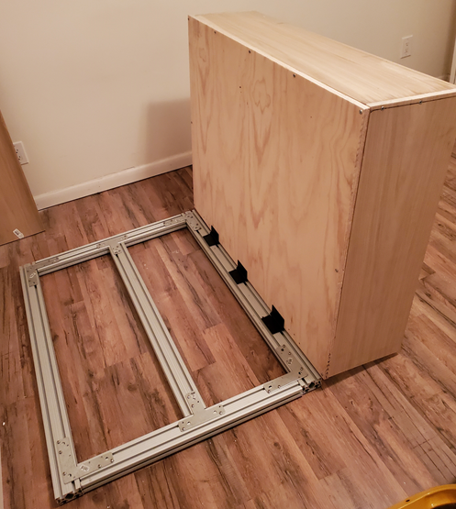

Team Member: Hope Williams
Action Item | Date Completed | Result/Proof of Completion
Submitted and received a Gorilla Cart Order | 2/24/2021 | 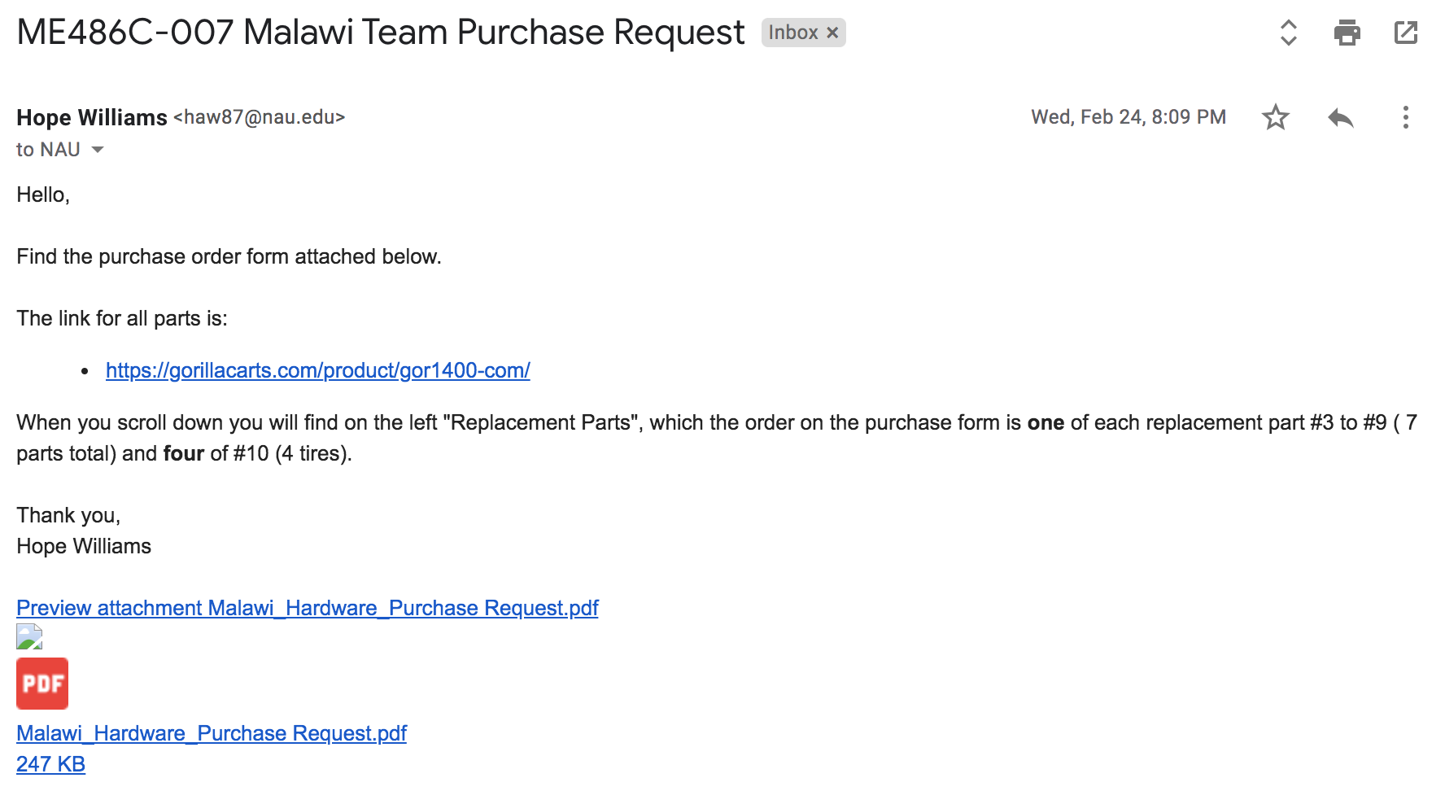
Went with the team to HomeCo to get items needed for the project. | 3/11/2021 | 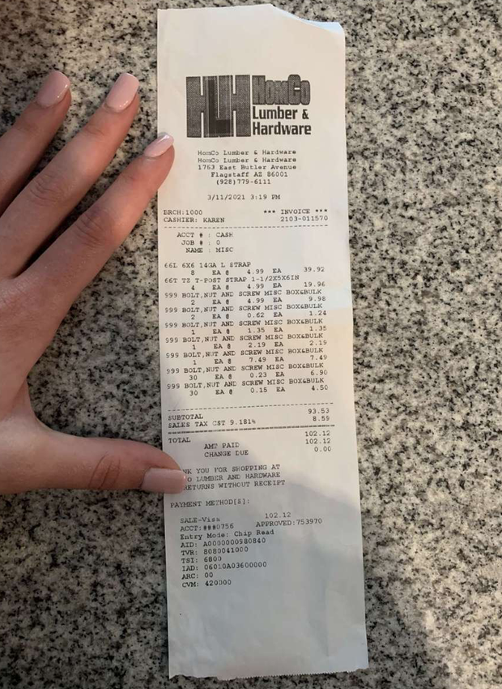
Submitted a Team Reimbursement form for purchases from Home Depot and HomeCo | 3/18/2021 | 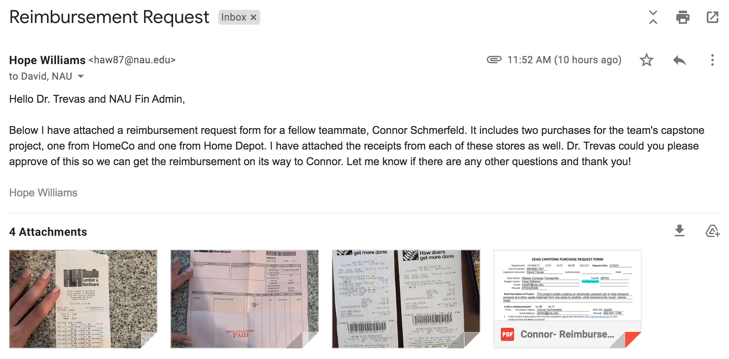
Met with the team at Connors house to start building the cart | 3/15/2021 | 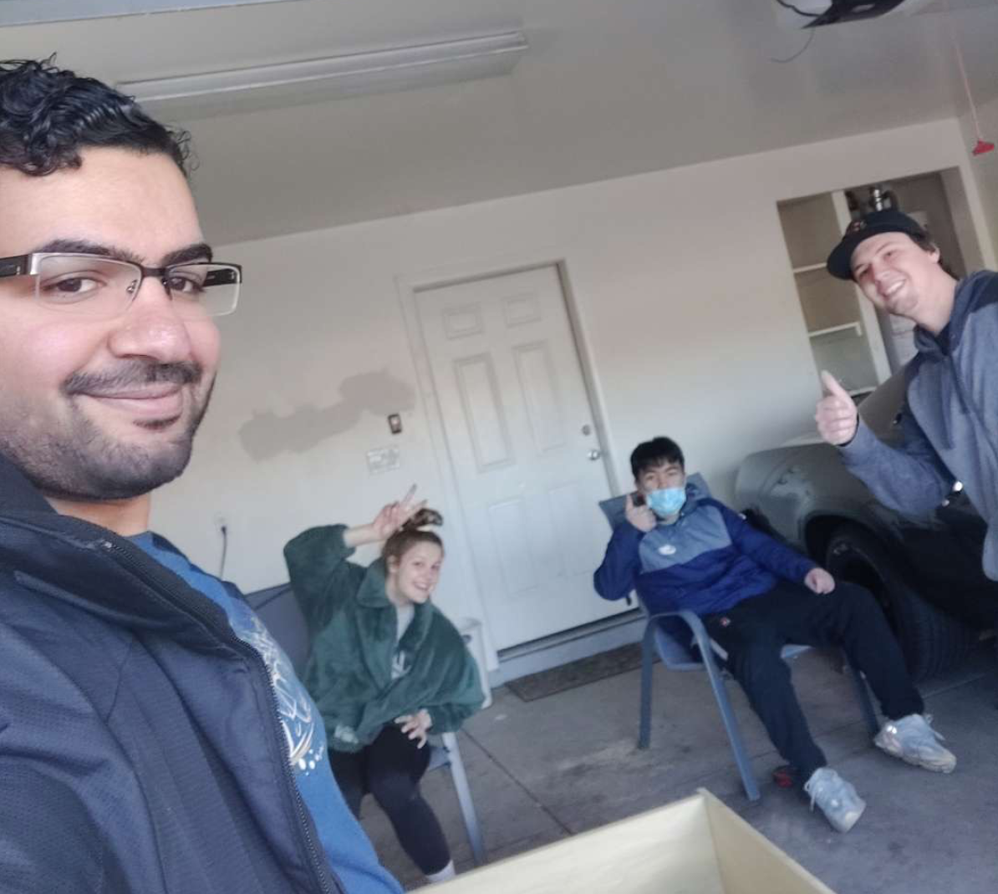
Team Member: Shi Zhang
Action Item | Date Completed | Result/Proof of Completion
Ordered and received an 8-ton hydraulic jack online | 2/1/2021 | 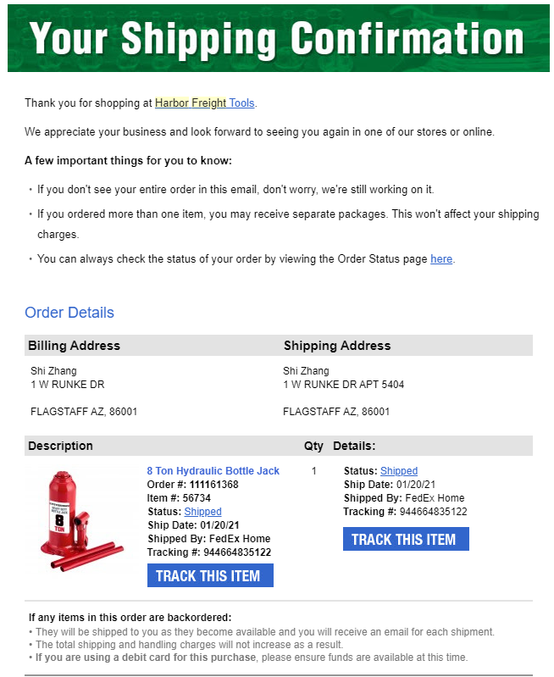
Went with the team to The Home Depot to get several PVC pipe for the project | 02/18/2021 | 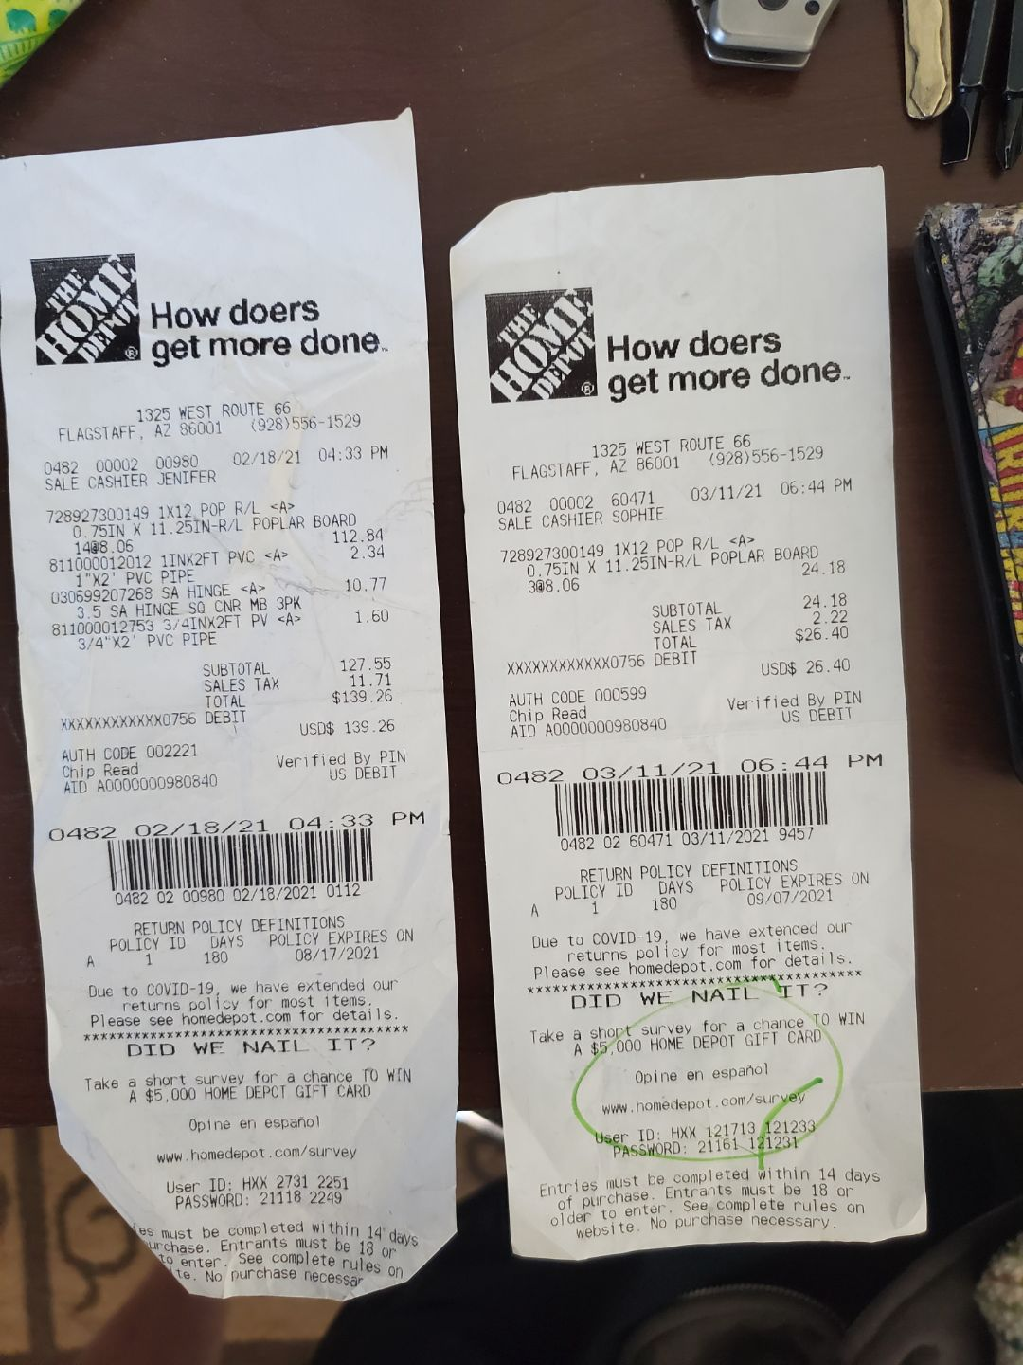
Met with the team at Connors house to start building the cart | 3/15/2021 | 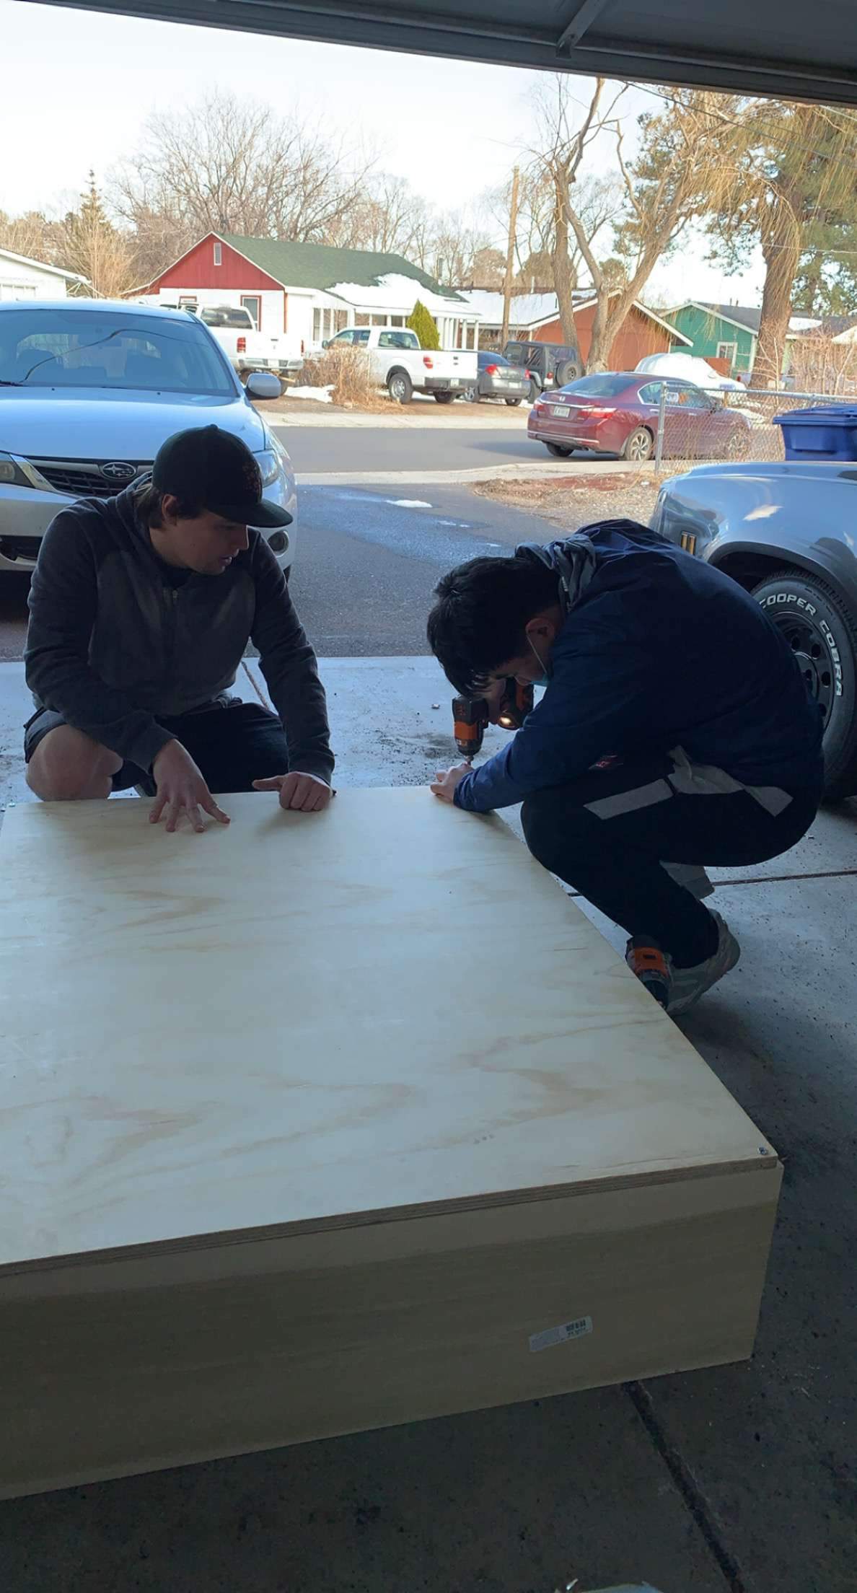

The following are the Action Items for each team member between HR 2 and the Final Product presentation:

Team Member | Action Items | Date Due
Husain Aldawood | - Finishing up the building process at Connor’s Place.  - Inflating the tires with foam.  - Finishing up the operation manual guide of our device. | - 4/9/2021  - 4/5/2021  - 4/12/2021
Connor Schmerfeld | - Get the wheels and handle mounted  - Get the entire project built, including basket and motor  - Conduct proper testing on the project for the final presentation. | - 3/23/2021  - 4/9/2021  - 4/23/2021
Hope Williams | - Order extra parts if needed  - Continue to build our prototype at Connor’s  - Start drafting the poster the team will present | - 4/30/2021  - 4/9/2021  - 4/23/2021
Shi Zhang | - Finish up the whole construction of our prototype  - Finish up the disassembly guide of our prototype  - Update our websites | - 4/9/2021  - 4/12/2021  - 4/23/2021

